Information Economics Worksheet 1
Attendee Notes

- When determining information economics, what are four factors that must be accounted for?

- What are some examples of distinct manual and digital systems that contain information?

- What are some methods for quantifying and extrapolating the volume of information objects?

- What are some examples of Asset Costs in determining TCO?

- What are some examples of Process Costs in determining TCO?

- What are some examples of Risk Costs in determining TCO?

Information Economics Worksheet 2
Session Notes

- When determining information economics, what are four factors that must be accounted for?
  - Volume
  - Asset Cost
  - Process Cost
  - Risk Cost

- What are some examples of distinct manual and digital systems that contain information?
  - Paper
  - Email
  - Local and Network Drives
  - Standalone Applications
  - ECM and Structured Systems

- What are some methods for quantifying and extrapolating the volume of information objects?
  - Paper: Device page counts, Lease and service agreements accounting, Consumable assessments
  - Emails: Server volume growth rate and associated costs, PST file scans, Sampling
  - Local and Network Drives: File analysis, Server and cloud storage
  - Applications: User counts, Servers, Native Metadata, Licenses
  - Structured Systems: User counts, Servers, Metadata, Licenses

- What are some examples of Asset Costs in determining TCO?

  - Invoices
  - P-Card sampling
  - Fixed resource cost (Support personnel)
  - M&S agreements
  - Cloud subscriptions
  - Consumables
  - Real estate
  - Migration
  - Shipping costs
  - Scanning
  - Specialized equipment (microform readers)
  - Offsite Storage
  - Application development

- What are some examples of Process Costs in determining TCO?
  - Time and motion studies
  - Representative process mapping
  - Resource costs to create, use, transmit, store, recall and translate information
  - Process examples for Transient, Work in progress/reference, and Record-quality information
  - Process examples using different systems, departments

- What are some examples of Risk Costs in determining TCO?

  - Litigation spend
  - Regulatory fines
  - Cyber insurance
  - Threat detection and monitoring
  - Opportunity cost
  - Obsolescence
  - Reputation/publicity
  - Customer experience
  - Training cost
  - Customer acquisition cost
  - Internal risk resource cost
  - Consumer protection
  - Insurance premiums
  - IMPEX / cost of change

Information Economics Handout 1
Calibration Questions

Consider the following questions and offer your best un-Googled answer. Also consider you’d win $20 for each response that was closer to exact than the average of the room. You don’t need to be correct, just more accurate than the two people sitting next to you!

# | Question | Lower Bound (95% chance value is higher) | Upper Bound (95% chance value is lower) | Answer | Correct?
1 | What percentage of bronze is typically made of copper?
2 | How many countries have at least one McDonald’s?
3 | What was the population of Miami (within the city limits, not the entire metropolitan area) in 1990?
4 | The Supremes’ (with Diana Ross) song “Stop! In the Name of Love” was how long? (minutes, seconds)
5 | How many gallons are in a bushel (they are both measures of volume)?
6 | How many sovereign rulers has England had in the last thousand years?
7 | Average cost of testing in software development is what percentage of total project costs?
8 | On average, if a software development project was projected to take 17 months, it actually takes how many months?
9 | In 2005, the average combined MPG for all US cars and light trucks on the road was how much?
10 | The average house in the United States uses how many gallons of water per day?

Reproduced from Calibration Questions from www.howtomeasureanything.com
Information Economics Handout 2
Sample Paper Volume and Cost Detail by Department

Department | November Objects | November Pages | Average Annual Objects | Average Annual Pages | Cost per Object | Cost per Year
Customer Service | 11,493 | 39,201 | 223,027 | 760,712 | $0.14 | $30,709.53
Engineering | 23,492 | 75,801 | 455,872 | 1,470,950 | $0.13 | $59,381.46
Environmental | 553 | 1,769 | 10,731 | 34,328 | $0.13 | $1,385.81
Field Operations | 3,052 | 12,126 | 59,225 | 235,310 | $0.16 | $9,499.34
Finance | 10,506 | 37,932 | 203,873 | 736,086 | $0.15 | $29,715.41
Gas Control | 2,056 | 6,738 | 39,898 | 130,754 | $0.13 | $5,278.46
Human Resources | 1,795 | 6,070 | 34,833 | 117,791 | $0.14 | $4,755.15
IT | 3,091 | 28,707 | 59,982 | 557,071 | $0.37 | $22,488.67
Legal | 3,148 | 15,957 | 61,088 | 309,652 | $0.20 | $12,500.50
Pipeline Safety | 1,076 | 8,843 | 20,880 | 171,602 | $0.33 | $6,927.48
Procurement | 2,818 | 8,562 | 54,684 | 166,149 | $0.12 | $6,707.35
Regulatory Affairs | 1,379 | 6,628 | 26,760 | 128,619 | $0.19 | $5,192.28
Safety & Risk | 557 | 1,876 | 10,809 | 36,405 | $0.14 | $1,469.63
Technical Services | 3,479 | 12,425 | 67,511 | 241,112 | $0.14 | $9,733.57
 | 68,495 | 262,635 | 1,329,174 | 5,096,543 | $0.15 | $205,744.66

Information Economics Handout 3
Sample Process Map with Swim Lanes

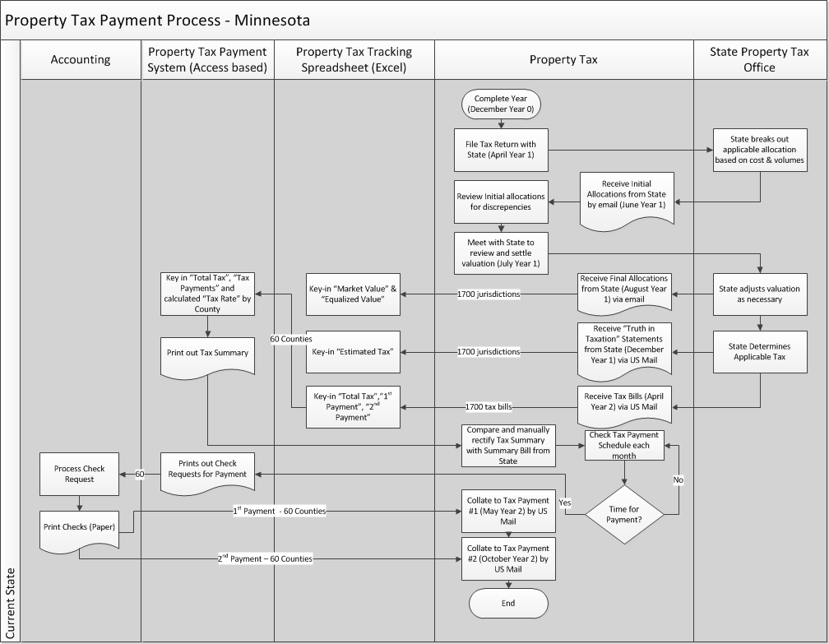

Information Economics Handout 4
Sample Risk Matrix Valuation

 |  | Considerations
 |  | Regulatory Compliance | Legal | Strategic | Technological | Operational | Financial / Nominal
Consequence | I | Severe violation | Corporate suit / audit | Public reputation | System failure / breach | Corporate,  >5M | $7,000,000.00
Consequence | II | Moderate / region violation | Regional / business line audit / suit | Disrupted operations, lost customer | System outage / interruption | Business,  500K-5M | $2,000,000.00
Consequence | III | Minor / site violation | Small fine | Operational efficiency / rework | System reboot | Site,  50K-500K | $200,000.00
Consequence | IV | Warning / citation | No significant impact | Internal process workaround | Performance Issue | Other,  <50K | $20,000.00
 |  | Qualitative Interpretation |  | Quantitative Range | Nominal
Probability | A | Possibility of Repeated Incidents |  | 100%-10% | 40%
Probability | B | Possibility of Isolated Incidents |  | 10%-1% | 4%
Probability | C | Possibility of Occurring Sometime |  | 1%-0.1% | 0.4%
Probability | D | Not Likely To Occur |  | 0.1%-.0.01% | 0.04%
Probability | E | Practically Impossible |  | <0.01% | 0.008%
 |  | Probability
 |  | A | B | C | D | E
Consequence | I | $2,800,000 | $280,000 | $28,000 | $2,800 | $560
Consequence | II | $800,000 | $80,000 | $8,000 | $800 | $160
Consequence | III | $80,000 | $8,000 | $800 | $80 | $16
Consequence | IV | $8,000 | $800 | $80 | $8 | $2
Risk Level |  | Category 1 |  | Category 2 |  | Category 3
Nominal Impact |  | 1 |  | 2 |  | 3
 |  | $678,000.00 |  | $4,171 |  | $129

